

|  |  |  |  |  |  |
| --- | --- | --- | --- | --- | --- |
| Programme | : | **B.Tech (CSE)** | Semester | : | **Fall 2016** |
| Course | : | **Internet and Web Programming (Embedded Lab)** | Code | : | **CSE3002** |
| Faculty | : | **Prof. Rajiv Vincent**  **Prof. M.Premalatha** | Slot | : | **L7+L8** |

**Ex. No: 9**

**Date: 13/9/16**

**PHP with Forms and Validation**

Note: All fields are mandatory and has to be validated using regular expressions

Form Design:

1. Enter the from station, to station and date details and submit the details

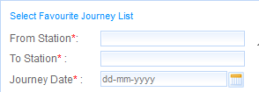



1. List the trains which runs between the stations as below

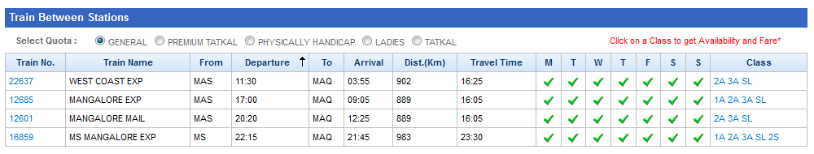

1. Select a class from a train and book the ticket

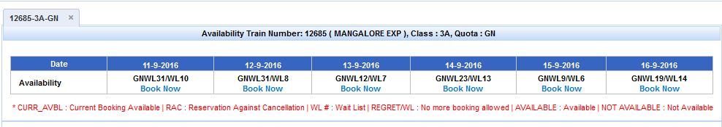

1. Fill the passenger details

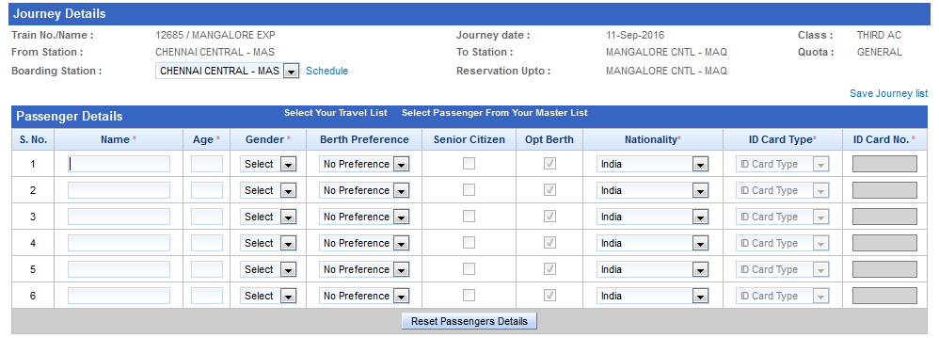

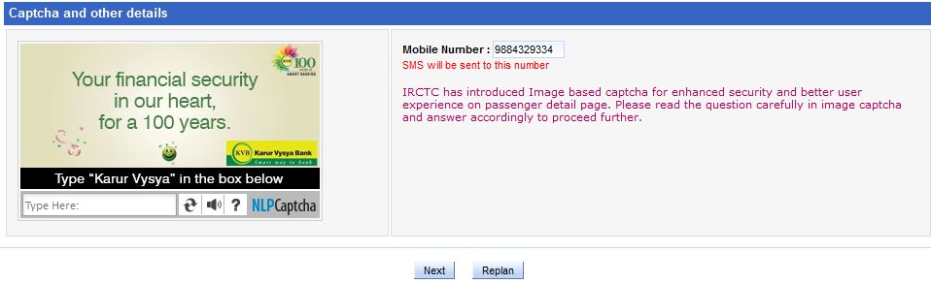

1. Once the details are filled, display the ticket details

